OCCUPATIONAL THERAPY – Advice Sheet

HANDWRITING - PENCIL GRASP

Research shows that people use a wide variety of pencil grasps, and develop for themselves a grip that is functional and works well. There is a range of ways to hold a pencil and children tend to use the one that is most useful to them. A well-developed pencil grasp allows the pencil to be moved in a fluent, controlled way.

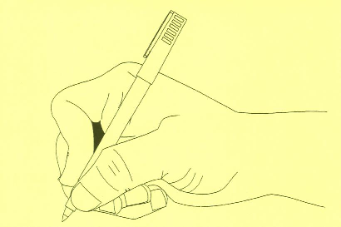
The most commonly used pencil grasp is the “tripod” grasp, with thumb and index finger grasping the shaft of the pencil, which then rests on the side of the middle finger on an angle of around 40 degrees to the line of the thumb and forearm. Writers who use the “tripod” grip tend to be efficient writers who do not suffer from writing fatigue.

Research shows that those who use an alternative grip to the ‘tripod’ will not necessarily have untidy, slow writing or suffer fatigue in the fingers. A tripod pencil grasp begins to emerge in children at about 4 years of age and takes time to be consistently established. Children vary in how they develop these skills and those with delayed development tend to establish this skill much later than this.

When considering changing a child’s pencil grip it is important to think about why you want to change it, especially when a child is young. Generally kids will develop an effective position for themselves over time.

Reasons for changing it would be;
- if their hand/grasp position is blocking visual view of the tip of their pencil and their work
- if they complain of sore or tired hands
- There is an underlying condition and you want to prevent damage to joints and tendons E.g. arthritis or hypermobile joints.

Research shows that different styles of pencils e.g. thick pens, triangular pencil grips etc. do not have much effect at improving writing/drawing. The main factors influencing a child’s drawing/writing development are;
- their motivation to do the task – enjoying and being interested in participating
- practice -an important factors in acquiring new motor skills
- their ability to problem solve.

Other strategies to consider include:
- Assistive technology; this may include use of devices or specialist software.
- Slope boards
- Ergonomic set-up, e.g. feet resting on a flat surface, appropriate table height.
- Environmental set-up, e.g. visual distractions, position in classroom relative to teacher/ whiteboard

