PROFESSIONAL DEVELOPMENT & CAREER PLAN
NURSING
Career planning is a continuous process of self-assessment and goal setting. This plan incorporates your career and professional development aspirations and aligns these with organisational goals as reflected in your role description. The Chief Nursing Officer (CNO) 2 DHB manages Health Workforce funding for nurses. A requirement for accessing this funding is to attain the appropriate level of the Nursing Professional Development and Recognition Programme (PDRP) and have an agreed Professional Development and Career Plan (PDCP). Professional development activities require a feedback loop (report on outcomes) as part of the follow-up for activities supported by the organisation. This link provides further information on the career planning process. http://www.healthworkforce.govt.nz/health-careers/career-planning. Before starting your career plan, it’s important to work through the career planning process, so that your plan is realistic and achievable for you, taking into account your self assessment (Know Yourself) and your career research (Explore Possibilities). Consider what knowledge and skills you need to fulfil the role description (i.e. clinical competences and professional behaviours) and meet objectives and develop in your career. |  |  |  |  |  |  |  |  | 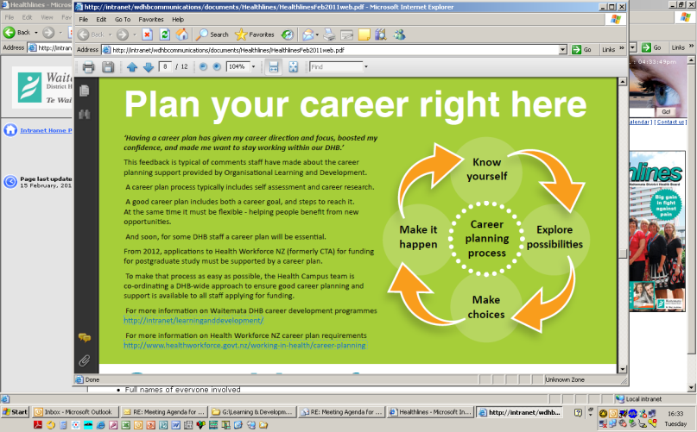
Career Plan for: |  |  |  |  |  | Date:
 |  | Career &/or Professional Development Goals | Action Plan to Achieve Goals |  |  |  |  | Timeframe for achievement

Short Term

(within 1 year)

Longer Term

(up to 5 years)
I have discussed my professional development and career aspirations with my line manager who is in agreement. |  |  |  | The plan meets the needs of the service and fits with the strategic direction of workforce development within the organisation. I have discussed this plan and agree to support the achievement of these goals.
Staff Member Sign Off: |  |  |  | Line Manager Sign Off:
Name: |  |  |  | Name:
Title: |  |  |  | Title:
Signature: |  |  |  | Signature:
Date: |  |  |  | Date:

