Student Nurses

Coronary Care Unit

6th Floor
Heretaunga Block
Hutt Hospital

O’Drive, Depts., CCU, Staff Orientation, Student Nurses R. Kitchen, KA, EE, J. Dean. 2023
The Coronary Care Unit

Welcome to the Coronary Care Unit (CCU) at Hutt Hospital. We hope that you will find this clinical placement interesting, challenging and a worthwhile experience.
We look forward to meeting you!

This information booklet will provide you with some useful background information about the CCU and Cardiology Department, and introduce you to some of the people you will met during your clinical placement.

Our goal is to provide you with excellent learning opportunities not only in caring for patients with cardiac disease, but also with other medical conditions. You will learn from the patients’ and our experienced team of staff.

Please ask any questions and seek clarification of things that you are not sure about.

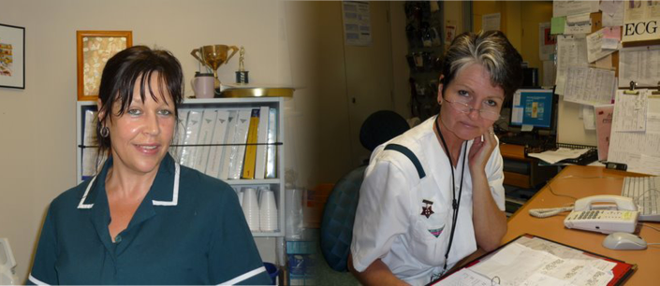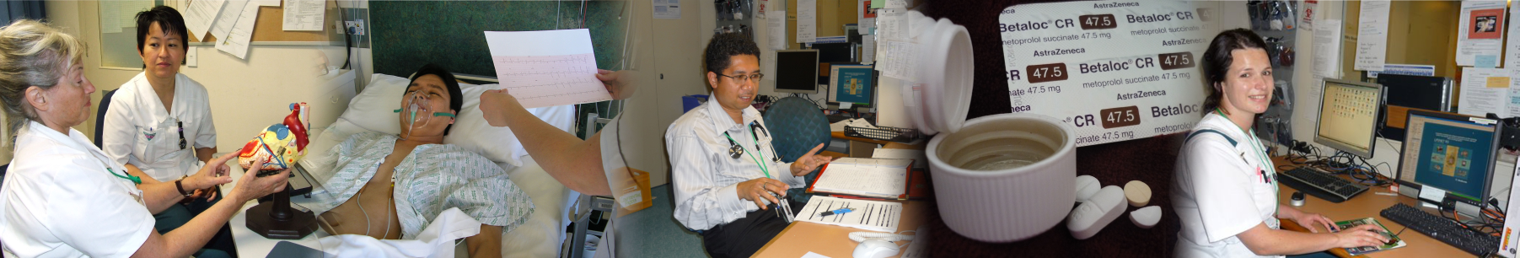

Hutt CCU:

CCU has 12 inpatient beds and is located on the level 6 of the Heretaunga Block of Hutt Hospital.

The majority of patients that you will meet in CCU will live within the Hutt Valley region (population approx. 142,000) and have been admitted to hospital for investigation or treatment of a cardiac related condition. They will have been assessed in either the emergency department (ED) or the medical assessment planning unit (MAPU) before being admitted to CCU. Occasionally patients are admitted directly to CCU from our outpatients department or from other hospitals.

We have a strong inpatient and community focus on promoting health and minimising suffering, disability and premature death for adult patients with a cardiac condition.

While on clinical placement you will meet people with a diagnosis of:
    - unstable angina
    - myocardial infarction (heart attack)
    - arrhythmias
    - heart failure

Members Of Our Team:

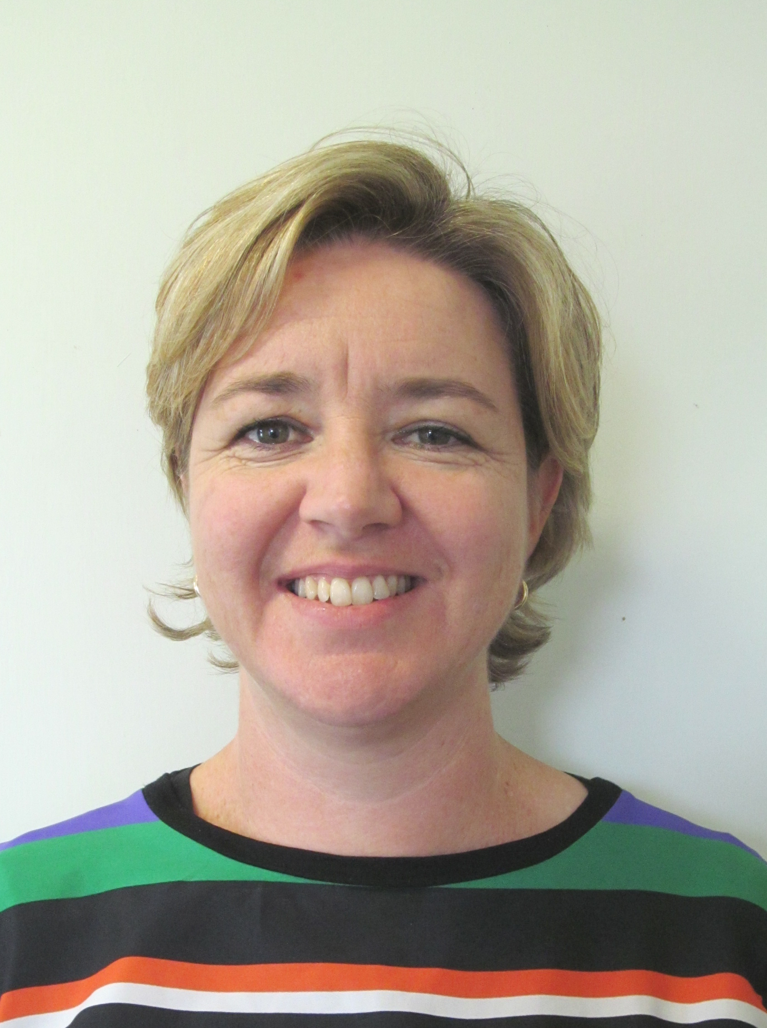

Jennie Dean and Dr Katherine Ferrier

Charge Nurse Manager Clinical Head of Department

Medical Staff:

We have 5 cardiologists who work a part time rotating roster.

They are: Kathy Ferrier (Clinical Head of Department)
Tim O’Meeghan
Russell Anscombe
Susan Plunkett
Mohammed Moharram

The cardiologists are assisted by a team of four cardiac registrars and 1-2 house surgeons. They care for cardiac patients on the unit, in others wards throughout the hospital, in the emergency department and in outpatient clinics. Occasionally a trainee intern is rostered for six-week periods.

All cardiac inpatients are seen daily by the unit registrar and/ or consultant.
Please attend these rounds when doctors are with your patients as you will learn from the discussion that occurs.

Nursing staff:

Senior nurses include:
Clinical Nurse Manager: Jennie Dean
Clinical Nurse Manager Cardiology outpatients 2DHB: Jennifer Roberts
Clinical Nurse Educator: Robyn Kitchen
Clinical Nurse Specialists: Naila Rahman, Maryanne Jillett, Sarah Rossiter and Zari Diedrichs-Faman

AM shift: a Shift Coordinator, 3-4 Registered Nurses (RN) and an
Health Care Assistant, +/- D shift.
PM shift: 3 RN’s, and an HCA until 4pm (except Saturday AM – 4 RN’s)
Night shift: 2- 3 RN’s

The unit works closely with Cardiac Nurse Specialists who run Outpatients Clinics, provide a discharge follow-up phone call, visit patients in their own home if required, and facilitate rehabilitation programs. Continuity of care and education is provided in order to support patients as they recover from an event for unstable angina, myocardial infarction, arrhythmia, heart failure or post cardiac surgery. You will also see those visiting patients on the ward. Feel free to join them.
The cardiology cardiac rehabilitation programme runs each Tuesday and it would be useful for you to attend this.

Other MDT members:

The input required from other health professionals has increased over recent years due to increasing complexity of patient needs. This relates primarily to our aging population and patients’ having many co-morbidities or chronic conditions.

Social Worker - Assess patients’ social situations focusing on the person & their support systems. This assessment may identify the need for referrals to be made to other agencies and organizations’ to put in place things like home help, meals on wheels etc.

Maori Health and Pacific Island Health Teams - Meet with Maori/Pacific patients as appropriate to provide for their cultural needs.

Pharmacist - Ensure correct charting of drugs, no contraindications, and provide education to patients about drugs as appropriate.

Occupational Therapist - Assess patients to improve their ability to perform tasks in their daily lives. If problems are identified the appropriate aids can be issued. They also perform cognitive assessments.

Physiotherapist - Assess patients’ mobility & issue mobility aids as appropriate. They also provide chest physio for patients with chest infections or recovering from cardiac surgery.

Dietitian - Assess patients’ nutritional requirements and provide appropriate education.

Chaplain - Care for the spiritual needs of patients. They provide a 24 hour service so are available on call as required.

Contacts:

Unit Telephone Number |  | 570 9041
Clinical Nurse Manager | Jennie Dean | 570 9108  Email : jennie.dean@huttvalleydhb.org.nz
Nurse Educator | Robyn Kitchen  (part time) | Email: robyn.kitchen@huttvalleydhb.org.nz

Please contact the CCU if you are unwell, unable to come for any reason, and if you have any concerns through out your placement please discuss this with either Robyn or Jennie or your clinical tutor.

Preceptor:

Since we are a small unit, the majority of our nursing staff work rotating duties and work part time. We will endeavor to allocate you one main preceptor who will be responsible for helping you complete your objectives. However this is not always possible and you will find you are working with several nurses during your placement with us. Our aim is provide you with a great learning opportunity in order for you to achieve your potential.

Please tell the nurse you are working with what your objectives are for the day / week. So we can help you meet these goals.

If you require any written evaluations to be completed during your placement please inform your preceptor early in the placement. These will not get completed if they are presented to the preceptor on the due date or the day before!

There are meetings and training sessions for RN’s to attend which are not always appropriate for students. Please check with your coordinator before attending any sessions.

Expectations:

Shifts:

To find out what shifts you are doing please contact either the shift coordinator or Robyn Kitchen (570 9041) before starting your placement.

Morning (A) | 0700hrs to 1530hrs
Afternoon (P) | 1445hrs to 2315hrs
Night (N)  Entry at night is only via the Emergency Department | 2245hrs to 0715hrs
Cardiac Rehab and Heart Failure Nurse Clinic ( CL-8) | 0830hrs to 1700hrs

Student uniform with your ID showing is expected when working in this area and when going into the community with a cardiac nurse specialist.

If you find the 6th floor door is locked, use the intercom system on the wall and await for a reply. Someone will let you in.

Parking:

Parking costs on hospital grounds applies for all. If you want free parking we suggest you try High Street (at front of Hospital), Pilmuir Street (at back of Hospital), or side streets around the hospital.

General Ground Rules:

We have a few expectations of all students working in the coronary care
- On the first day please provide Student contact details (form at back)
And give it to either the CNE or the Shift Coordinator.

It is expected that you arrive on time for your shift and if you are going to be late or you are unwell and can not come, call the unit on 570 9041.

- You must complete the full shift that you are allocated to work – if you are unable to do so please discuss this with your preceptor or shift coordinator. A lot of learning occurs at quiet times in the unit!

- Do not bring valuables to work / leave unattended – these are your responsibility. There are lockers available for your use.

- A clean uniform must be worn, long hair must be tied back and cardigans must not be worn when working on the floor for infection control reasons.

- If you are not achieving your objectives please talk to either your Preceptor, CNE or Clinical Tutor, before the last week of your placement.

- Ask questions. Remember no question is a dumb question.

HVDHB is a smoke free hospital. Smoking during work hours, or smelling of cigarette smoke is not tolerated while working in the Coronary Care Unit.

Patient Information / Education:

A booklet containing unit information is in each room and shown to all patients admitted to CCU. This is for the relatives to read also. Patients are also provided with one to one explanations, DVD’s, booklets and folders, pamphlets, models to help their learning their heart condition.

Become familiar with these during your stay to enhance your knowledge and understanding of heart disease.

Visiting hours:

Many patients have had poor sleep, long hours undergoing assessment/treatment, so please encourage times for rest. Visitors are welcome between 8.00am-8.00 pm, with a compulsory no visiting rest period from 12.30-2.30 pm. Please encourage only two visitors at a time, especially in the 4-bedded cubicles. In the case of very ill patients, visitors are usually welcome at all hours. We would usually try to accommodate patients in a single room, if relatives are staying with them overnight.

Safety Measures:

Emergency number: 777

This number is used for all in hospital emergencies such as fire, security incident and adult and child cardiac arrests. On your first day ask your preceptor to show you the emergency exits, fire equipment, emergency trolley and emergency call bell system.

This is a good opportunity to discuss with your preceptor what you should do if you come across a patient who is unwell.

Have a look at the emergency management folder, on line infection control policies and our hazards register.

Central Cardiac Monitoring System – Do Not Touch

Telemetry units and monitor use require full supervision by an RN. This monitors the patient’s heart rhythm and rate. It is available to not only patients in the unit, but in other areas in the hospital with the use of portable telemetry units.

Only staff who have had training in the use of this monitor can enter or discharge patients from this system or alter patient parameters.

Telephone Calls to CCU

A cordless phone is available to take to the patient’s bedside. We encourage the patient (or representative) to convey information to family and friends so that staff do not have to attend numerous patient enquiry calls.

It does help if you can answer the phone at any time and pass on to the appropriate staff. As we have a part time ward clerk to answer phones, this becomes a shared responsibility.
Patient Code of Rights

Be familiar with the Health and Disability Code of Rights that applies to all patients receiving health care.

Please pass on any concern which a patient or person expresses. All feedback or issues are important information.

Treasure Hunt:

This list is designed to help you become familiar with the environment, but is by no means exhaustive of all the things you will be required to locate.

 |  | Emergency Exits |  | Patient Notes & Charts
 |  | Dangerous Drug Cupboard |  | Public/Patient Telephone
 |  | Photocopy/Fax Machine |  | Procedure Room & Supplies
 |  | Linen Supplies & Dirty Laundry skips |  | Blood Glucose Machine
 |  | Clinical Nurse Manager and  Nurse Educators Offices |  | Lamson Tube System
 |  | ECG Machine |  | Handover Room
 |  | IV Supplies |  |  Telemetry batteries & bags
 |  | Staff Tea Room/Toilet |  |  computer on wheels
 |  | Cleaners Room |  |  Hospital phone & fax numbers
 |  | Public Toilet
 |  | Prep/Drug Room
 |  | Portable and Fixed Observation Machines
 |  | Tympanic Thermometer Probe Covers
 |  | Wheelchairs, Walking Frame/Stick
 |  | Emergency Resus Trolley
 |  | Where to store your bag
 |  | Patient Beverage Bays
 |  | Cardiac Monitoring System
 |  | “Notes on Injectable Drugs” Manual
 |  | Roster
 | Manual BP Machines/Stethoscopes
 | Suction Equipment  (Emergency & Bedside)
 | Bio-Hazard bags

Objectives:

We do expect you to have done some pre-reading on cardiac conditions prior to your placement, common conditions include heart failure, heart attack, and heart arrhythmias (especially atrial fibrillation).

Your preceptor will work with you to help you learn about assessment and management of a variety of conditions relevant to CCU.

It is a good idea to develop some of your own objectives for your time in CCU, but here are some ideas of objectives you should be able to complete.

Objective (with appropriate supervision) | Date achieved
Admission of a patient to CCU
Discharge of a patient from CCU
Taking an ECG, basic interpretation
Taking and recording manual and automated BP and pulse, oxygen saturation, respirations, and temperature.
Discuss the interpretation of the findings.
Giving oral medications and explanation to patient of what they are
Daily hygiene cares
Managing a fluid balance chart
Daily weigh, documentation and understanding the importance of procedure.
Taking a patient load and planning your daily workload
Spend day with cardiac rehabilitation and heart failure nurse
Educating a patient about angina/MI & use of GTN
Handing over to the next shift using dictaphone
Writing daily nursing notes
Assessment of symptoms and chest discomfort
Differential diagnosis of chest pain
CCU guidelines of patient care and care plan
Trend care, Webpass, Patient assessments on trendcare

Common CCU Presentations:

Common conditions you are likely to see in CCU are listed below. Begin to do some reading about these conditions prior to your placement and write a brief note when you have some understanding of each.

ACUTE CORONARY SYNDROMES:

ANGINA:

NSTEMI:

STEMI:

CONGESTIVE HEART FAILURE:

ATRIAL FIBRILLATION:

Medications:

Drug Group | Examples | Purpose, Action, Side Effects
Beta Blockers | Metoprolol
Calcium Channel Blockers | Diltiazem  Felodipine
Ace Inhibitors | Cilazapril  Accupril
Diuretics | Frusemide  Spironolactone  Metolazone
Analgesia | Morphine  Fentanyl
Statins | Atorvastatin
Anti-Platelets | Aspirin  Clopidogrel  Ticagrelor
Anticoagulants | Clexane  Warfarin  Dabigatran  Rivaroxaban (1/8/18)
Nitrates | Duride  GTN spray

Useful Abbreviations:
Below is a list of common abbreviations you will see used on handover sheets and throughout documentation in Coronary Care Unit.

ACP | Advanced Care Planning
AF | Atrial Fibrillation
CABG | Coronary Artery Bypass Graft
CHB | Complete Heart Block
CHF | Congestive Heart Failure
COPD | Chronic Obstructive Pulmonary Disease
CVL | Central Venous Line
DCM | Dilated Cardiomyopathy
ECG | Electrocardiograph
EMB | Early morning breakfast
FBC | Fluid Balance Chart (nursing) Full Blood Count (medical)
GTN | Glyceryl Trinitrate
HTN | Hypertension
ICD | Implantable Cardioverter-Defibrillator
IDC | Indwelling Catheter
IHD | Ischemic Heart Disease
IVAB | Intravenous Antibiotic
IVC | Intravenous Cannula
IVF | Intravenous Fluids
LAD | Left Anterior Descending (Artery)
LBBB | Left Bundle Branch Block
NRT | Nicotine Replacement Therapy
NSTEMI | Non ST Elevation Myocardial Infarction
PAMI | Primary Angioplasty for Myocardial Infarction
PCI | Percutaneous Intervention
PICC | Peripherally Inserted Central Catheter
PPM | Permanent Pacemaker
RCA | Right Coronary Artery
STEMI | ST Elevation Myocardial Infarction
TAW | Te Ara Whakapiri
VF | Ventricular Fibrillation
VT | Ventricular Tachycardia

Pre-reading / Resources:

You may wish to view some interesting journal articles and websites:

- O’Donovan, Kate. (2011), Assessment of chest pain. (Module 17, Part 9). WIN, 19, 9, 33-35.

- New Zealand Heart foundation website – for patient information resources including: Heart Attack, Heart Failure, Atrial Fibrillation & Valve Disease.

- https://www.skillstat.com/tools/ecg-simulator - good to look at normal and abnormal heart rhythms.

- Look at the Cardiac section of your A&P book.

Evaluation of your Clinical Preceptor
Cut along line
------------------------------------------------------------------------------------------------------------------------------------------------------------------------------------------------------------------------------------------------------------------------------

Please return your evaluation to Robyn (CNE) or Jennie (CNM)

Name of Preceptor_____________________________________ Date_________________
E = Excellent VG = Very Good S = Satisfactory NI = Needs Improvement

Please read the following statements then tick the box that best indicates your experience
My Preceptor: | E | VG | S | NI
Was welcoming and expecting me on the first day

Was a good role model and demonstrated safe and competent clinical practice

Was approachable and supportive

Acknowledged my previous life skills and knowledge

Provided me with feedback in relation to my clinical development

Provided me with formal and informal learning opportunities

Applied adult teaching principals when teaching in the clinical environment

Describe what your preceptor did well

Describe anything you would like done differently

Signed:____________________________ Name:__________________________

Notes

Please use this space for notes.

Student Contact Details for CCU
The nurses on CCU care about your well-being as well as your education. They will notice and be concerned if you don’t arrive for a planned shift, if there is illness on the ward or in the case of an emergency. They may need to contact you to check you’re ok and to let you know if there needs to be a change to your shifts.
Please could you provide the ward with your contact details and an emergency contact using the form below?

This information will be kept in the back of the unit roster for the length of this placement and then will be destroyed. It will not be shared with anyone else without
your permission unless there is an emergency.

Your Name
Your Home Telephone Number
Your Mobile Telephone Number
Name of Emergency Contact
Telephone Number of Emergency Contact

Contacting your Tutor/CTA:

From time to time the staff on CCU may need to contact your tutor regarding your progress, for support or in the case of problems.
Please could you supply the contact details for the tutor/CTA that will be supporting you during this placement, in the form below?

Name of Tutor/CTA

Telephone Number for Tutor/CTA

Please complete a new form before each new placement and give it to the Senior Nursing Staff at the beginning of your placement.

Thank you.

