Hutt Valley District Health Board
Emergency Department

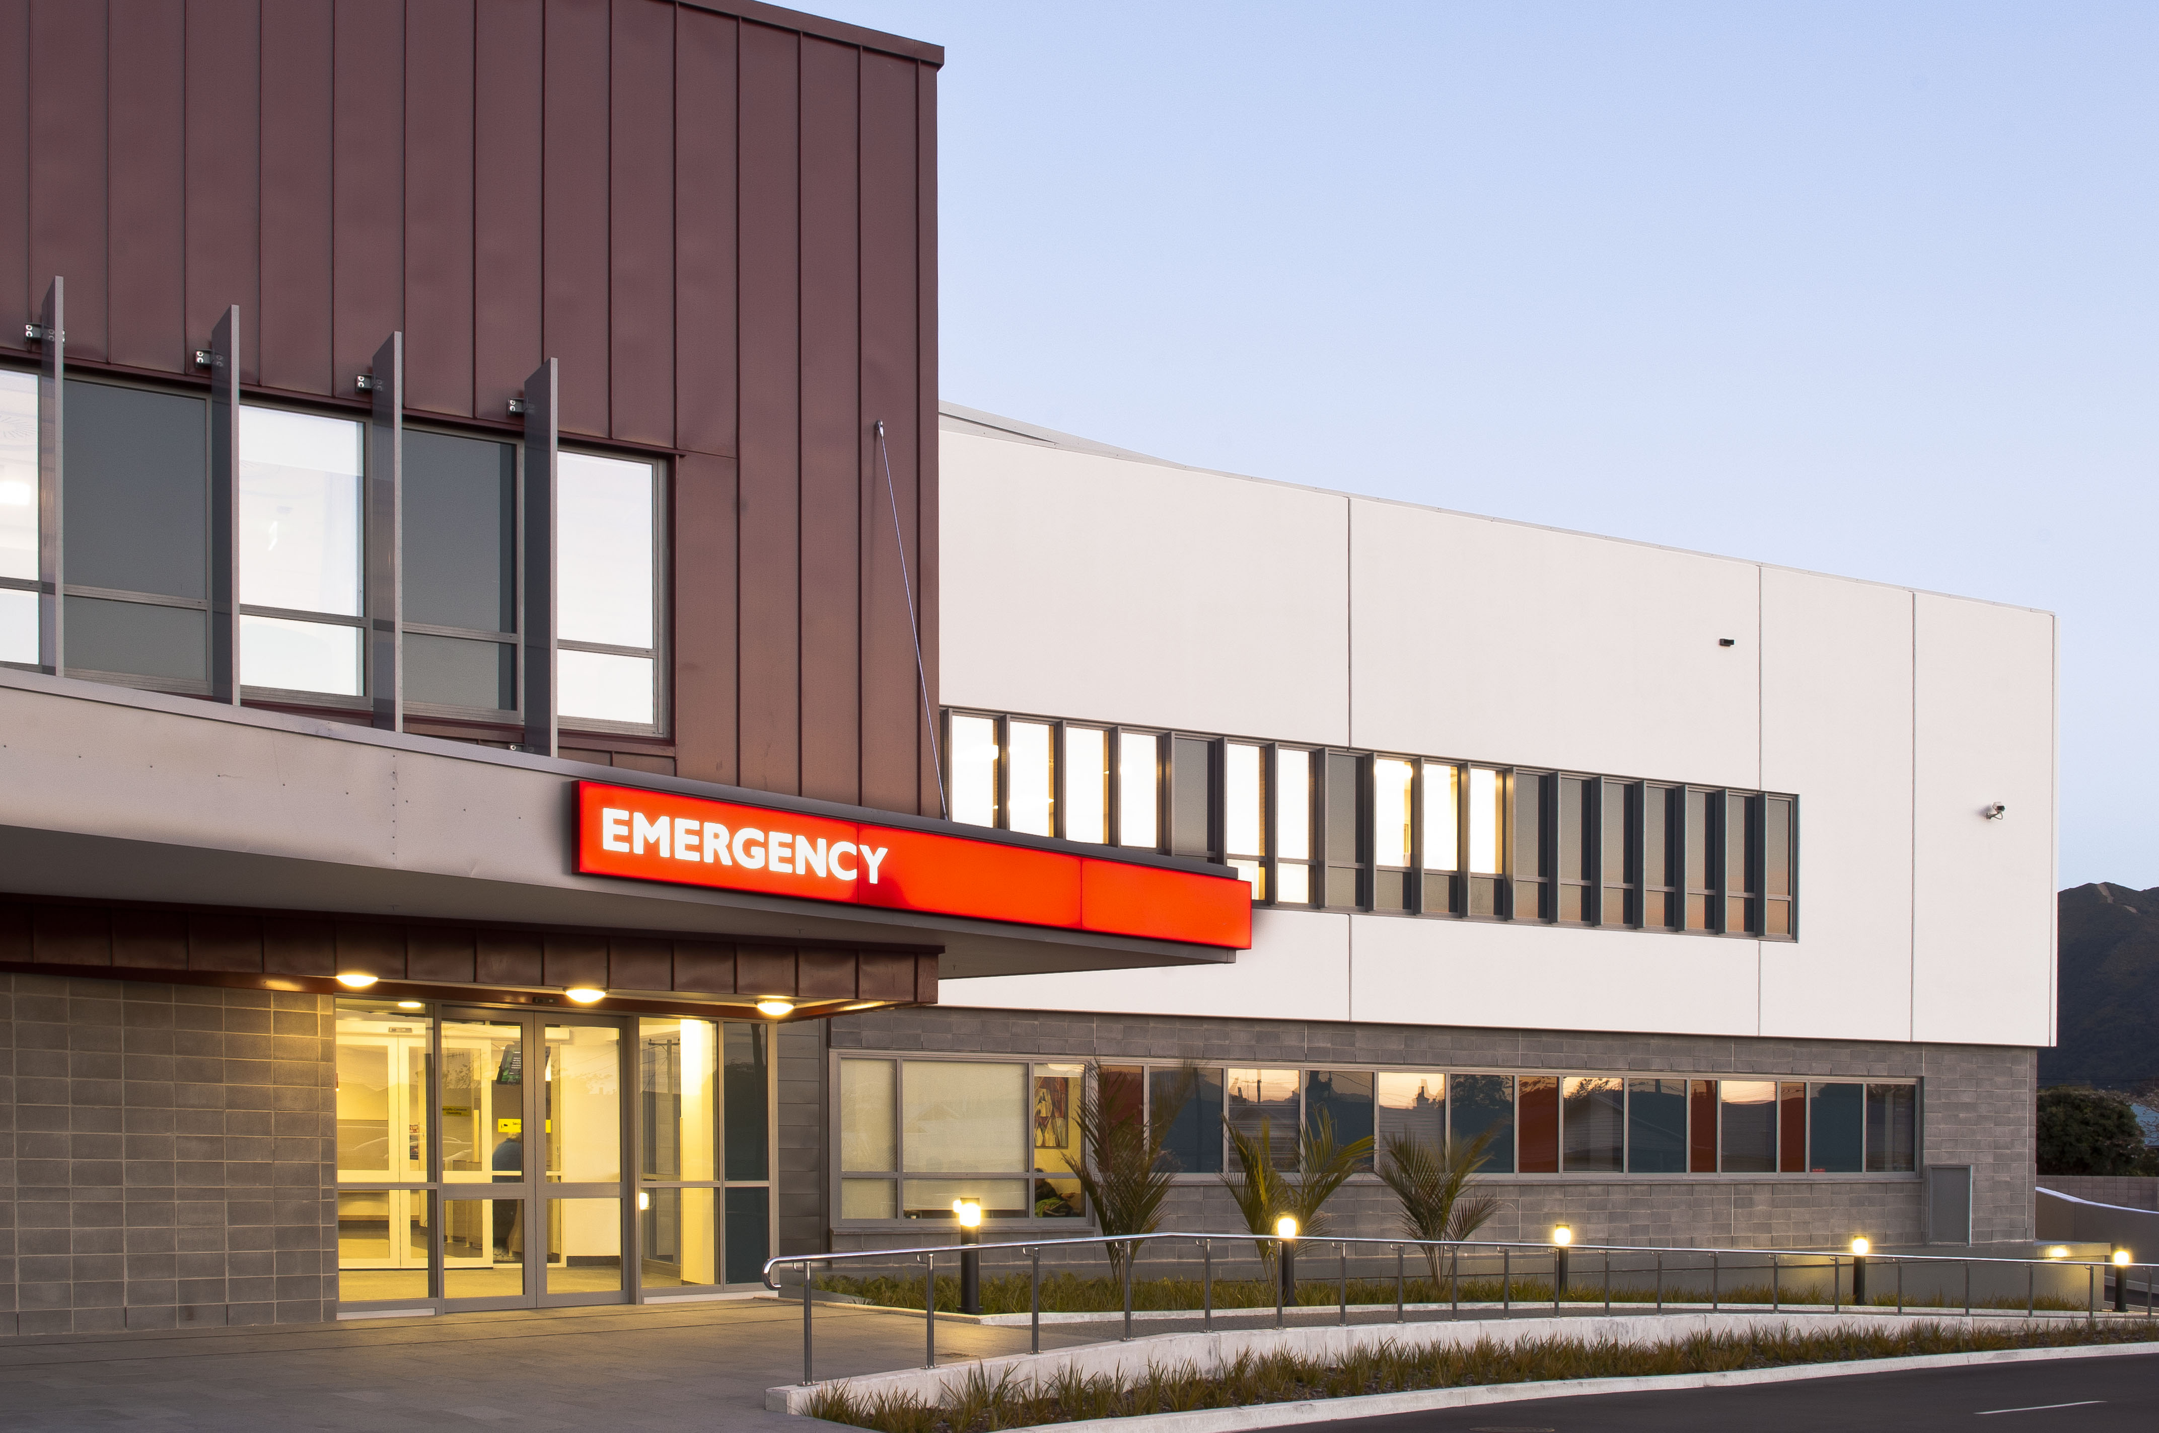

Clinical placement information for Nursing Students

WELCOME

Welcome to the one of the region’s largest and busiest Emergency Departments.
Hutt Emergency Department (ED) is a level 4 emergency care service and sees approximately 50,000 patients a year. Generally it is at its busiest in the winter months. Patient acuity ranges from `walking wounded` to life threatening emergencies such as cardiac arrest.
Most students are nervous when coming to this department but you will gain great experience, and a preceptor will always support you. Come prepared with learning objectives, and these need to be shown to your preceptors so we can help you achieve them.
Your preceptor will assist with meeting your objectives and completing required assessments. We aim to roster you to your primary nurse as much as possible but on occasion you will work with other members of staff.
If at any point during your placement you are facing difficulties, or need to talk to someone, your primary nurse should be your “1st point of call” and they will endeavour to resolve any problems you may have. Ben and Tracy (nurse educators) or one of the charge nurses on duty should be able to help you further if needed
The Department of Emergency Medicine is an excellent place for students to consolidate the theory they have learnt at college / university and put this theory into practice.
This requires a commitment (from you) to learning and willingness to be flexible in an ever changing environment.

Student Contact Details for Ward/department

Contact details
The staff on the ward/department care about your well-being as well as your education. They will notice and be concerned if you don’t arrive for a planned shift, if there is illness on the ward or in the case of an emergency. They may need to contact you to check you’re ok and to let you know if there needs to be a change to your shifts.
Your Name

Your Home Phone number
Your mobile phone number
Name of emergency contact
Phone number of emergency contact
Please could you provide the ward with your contact details and an emergency contact using the form below? This information will be kept by a senior staff member for the length of this placement and then will be destroyed. It will not be shared with anyone else without your permission unless there is an emergency.

Contacting your Tutor
From time to time the staff on the ward may need to contact your tutor regarding your progress, for support or in the case of problems.
Please could you supply the contact details for the tuto that will be supporting you during this placement, in the form below?
Name of Tutor

Phone number for Tutor

Please complete a new form before each new placement and give it to the senior staff at the beginning of your placement.

Thank you
(Please have this fill out and give to charge nurse on your first day)

THE EMERGENCY DEPARTMENT

The nature of an Emergency Department as you would expect is to see and treat emergencies and move them on to the appropriate definitive treatment or home. However, because we offer a free service and are the only facility consistently open 24/7 we see a huge range of patients from the community, presenting with a wide range of illness and injury.
We never turn away patients and endeavour to provide a high standard of care to all the patients and whanau who present to us. We work as a multidisciplinary team to achieve this. We work alongside numerous other specialties to help streamline treatment for our patients. Examples of other (daily) utilised services are WFA, MAPU, CATT, # clinic etc.

CONTACTS

Clinical Nurse Educators  Ben Ross & Tracy Langhorn |  | Ben.Ross@huttvalleydhb.org.nz  Tracy.Langhorn@huttvalleydhb.org.nz

Ben Ross or Tracy Langhorn will be organizing your placements and therefore are the people you need to contact concerning your rosters etc. Please contact them at least two weeks before your placement by email. If sickness please contact the educators via e-mail.
Most of the Emergency Department is swipe card access. When you start in the Emergency Department you will be issued a swipe card, but will need to provide a twenty dollar deposit which will be refunded to you when you leave.

EMERGENCY DEPARTMENT SHIFTS
Morning  D shift  F shift | : | 0700hrs to 1530hrs  0930hrs to 1800hrs  1200hrs to 2030hrs
Afternoon | : | 1445hrs to 2315hrs
Night | : | 2245hrs to 0715hrs

FIRST DAY
On your first day in the department, report to reception and state who you are and why you are here. You will be taken in for the shift handover where you will meet the nurse educators who will work with you for the first day.
Once you have met your nurse educators we will aim to give you a quick tour around the department. Please ask questions as appropriate about the area.
Your first day you will be spent with the nurse educator, it is important to become familiar with;
- The layout of the department
- Each treatment area- Triage, Resus, HD, Acutes, Sub -acutes
- Drug room
- Emergency equipment

TREASURE HUNT

This list is designed to help you become familiar with the environment, but is by no means exhaustive of all the things you will be required to locate.
 |  | IV fluid store |  |  | IV trolleys
 | Clinical policies & procedures
 |  | What are the login PW for students |  |  | “Notes on Injectable Drugs”
 |  | Linen supplies |  |  | Roster
 |  | Clinical Nurse Manager Office |  |  | Manual BP machine
 |  | CNE/ACNM Office |  |  | Suction Equipment
 |  | Where to store your bags |  |  | Bio-hazard bags
 |  | Store room |  |  | Tympanic thermometer covers
 |  | Staff tea room |  |  | Stationery supplies
 |  | District Nurse Referral |  |  | Photocopier
 |  | Xray facilities |  |  | Patient charts
 |  | Clean utility room |  |  | Laboratory forms
 |  | Utility trolleys |  |  | Fire safety equipment
 |  | Oxygen “shut off” valve |  |  | Lamson Tube system

TREASURE UNT

Locate, read and familiarise self with Disaster Manual
Familiarise self with Fire Drill
Locate Alarms for; Fire
Nurse/ Dr. Requiring assistance
Cardiac Arrest
Locate fire extinguishers.
Locate Dangerous Drugs D.D Cupboard
- Keys to D.D cupboard must be kept on a Registered nurse at all times. If leaving the
Department ensure keys are handed to another Registered E.D. nurses.
Familiarise self with I.V. Policy and Medications Policy.

YOUR PRECEPTOR
You will be allocated one main preceptor. This preceptor will be responsible for helping you completing your objectives. We will endeavor to ensure that you mainly work with this person, however, due to shift work, this is not always possible. It is your responsibility to ensure the nurse you are working with is aware of your objectives for the day/week.
You must provide evaluations and/or other paperwork to your preceptor in a timely fashion (i.e. not on the due date!!). Your preceptor will not complete any evaluations if you give it to them on your last days in the department.
Your preceptor will supervise you in regards to:
- Patient safety
- Own safety
- Own professionalism
- Communication with patients, relatives, the public, all other staff.
- Carrying out procedures
- Treatment of patients

PROFESSIONAL CONDUCT
- You must complete the full shift that you are allocated to work – if you are unable to do so please discuss this with your nurse, preceptor or nurse educators.
- It is important for your preceptor or the nurse you are working with that he/she is aware of your objectives
- Due to infection control a clean uniform must be worn, long hair must be tied back and cardigans must not be worn when working in the floor
- If you are not achieving your objectives please see the educators or your preceptor (before the last week in the unit)

PRIVACY
It is important that you are familiar with the Privacy Act and how it effects you when working in the Emergency Department.
- No information can be given to anyone without the patients consent, unless under the age of 16. Information can then only be given to the next of kin or guardian.
- If the patient is under 16 and the medical issue relates to that person’s pregnancy, then you are not able to release any information to any family member, regardless of the patient’s age.
- Any relevant information can be given to a police officer in person, who has identification. (This should be delegated to you preceptor or senior nurse on duty)
- Telephone advice/information must be given by senior nurses only.
- As a student it is expected that you will refer all such queries to your preceptor to deal with.
- Under no circumstances are you to give any information to the media. Redirect them to the Communications Officer or After Hours Managers.
- These precautions should save you from inadvertently giving information to the wrong person.
- When talking to patients try to be as discrete as possible. Remember that it is very easy to hear what is being said by people in the next cubicle.
- When talking to the patients over the counter remember that anyone standing nearby can hear the conversation. Please exercise caution and tact. Always be polite and keep calm. If a patient is rude that does not mean that you should reciprocate. As long as you remain calm, be understanding and polite you will have more chance of defusing any situation that could arise.
- The patient has the right to information concerning his/her condition. It must be given to them in language that they can understand.
- If English is their second language advocate for an appropriate interpreter.
- Keep the patient informed about what is happening. Do not assume that the Doctor has informed them.
- No photos should be taken in your time in ED
- The code of conduct directs the use of use of social media sites for health care professionals.
- The use of cell phones in the department should be put onto silent mode and only used in emergency while on the floor.

SAFETY MEASURES IN THE EMERGENCY DEPARTMENT
In the event of a cardiac arrest we have a red emergency alarm bell in every patient cubicle that can be pressed which will alert the whole department.
We also have a blue alarm bell in several areas which is a duress alarm that sounds throughout the department and alerts security in the event of a threat of violence.
We have fire cells in the Emergency department and in the event of a fire you will need to present to the Charge Nurse and be given instructions as to where we will gather and possibly move to.
Always maintain your own safety and that of the patients. If you, any other staff member or patients are ever threatened in any way, contact Security and/or the Police immediately.
Patients must not be left on trolleys without safety rails up if there is any concern for their safety.

ESCORTING PATIENTS WHO
- have an I.V. infusion,
- are unconscious
- being admitted to CCU., ICU
- going to yheatre from ED
- possibility of seizures
- Less than 15 minutes following IV Narcotics, less than 30 minutes following IM Narcotics
- Or you are concerned about in any way,
Must be escorted by a RN whenever leaving the Department

PATIENT VALUABLES
- It is preferable that patients valuables be handed to the next of kin and this documented on the patients records (to whom it was given, the person’s name and relationship to the patient)
- Patient’s property, if removed, should be put into a patient property bag and accompany the patient at all times
- If no one is accompanying the patient and he/she has valuables that need taking care of, place in a labelled envelope and lock it in the drug cupboard in the Emergency Department. Document this in the patient notes and when the patient goes to the ward take valuables with you and hand over to the receiving nurse.

OBJECTIVES
The Emergency Department provides a learning environment
- The provision of appropriate care to the patient and whanau with support and supervision from the preceptor, including
- Accurate assessment
- Competent implementation of care
- Documentation
- Referrals
- Gain an understanding of the multidisciplinary team
- Practice good infection control measures
- Pain management
- Fluid management/Fluid balance
- Wound management
- IV cannulation and phlebotomy

AREAS WITHIN THE EMERGENCY DEPARTMENT

RECEPTION
Often the first contact patients and relatives have is at reception. Our reception staff are key to the flow of the department and deal with a whole range of inquiries as well as processing patients electronically. The triage nurse works closely with the reception staff.

TRIAGE
All patients arriving will see a triage nurse. Very ill patients may be transferred straight to a room and be triaged there. Triage nurses are experienced nurses, who have undergone additional training in order to make a rapid assessment of a patient’s condition. There are two triage nurses on morning and afternoon shifts and two separate triaging areas. One at the front desk and one at the ambo doors.
Triage Nurses (Grey scrubs)
The Triage nurse is an experienced ED nurse who:
- Triage the patients as they come into the department. This includes documenting the triage assessment and attending to any immediate care the patient may need.
- Have an overview of the situation in the waiting room.
- In event of delay, keep people in the waiting room informed of what is happening
- Secondary assessment and management of patients in the waiting room.
- Assign patients disposition in consultation with the Charge Nurse.

Triage Area one:
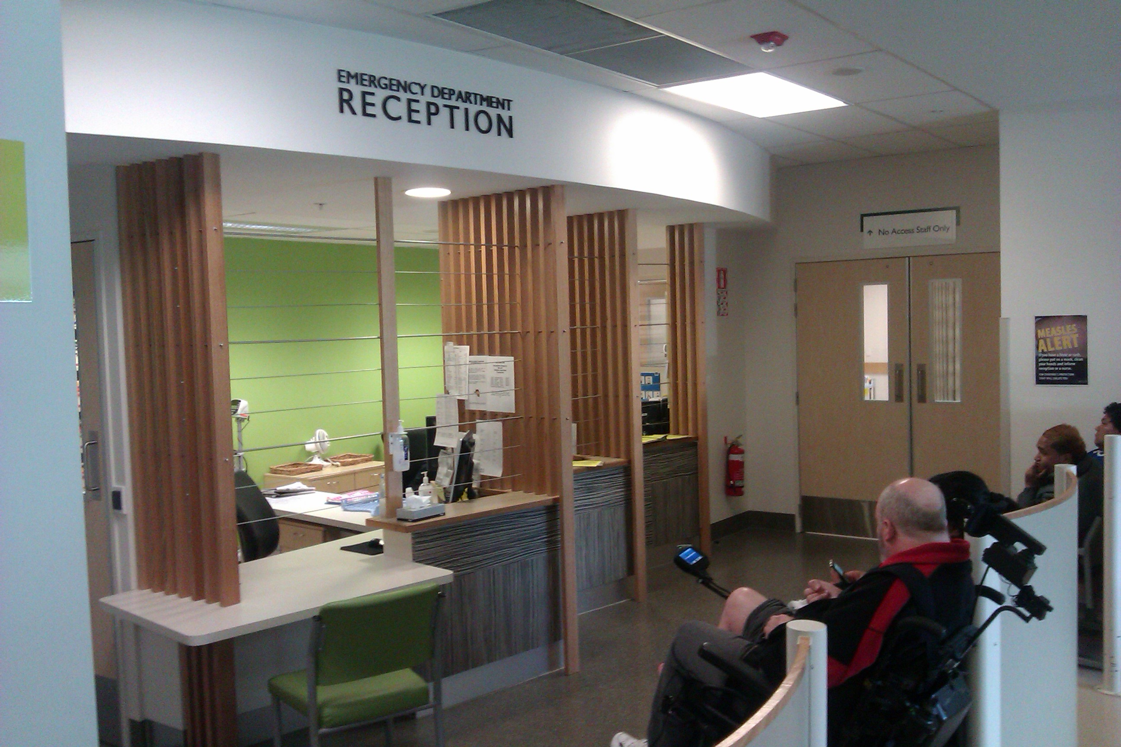

Triage Area two
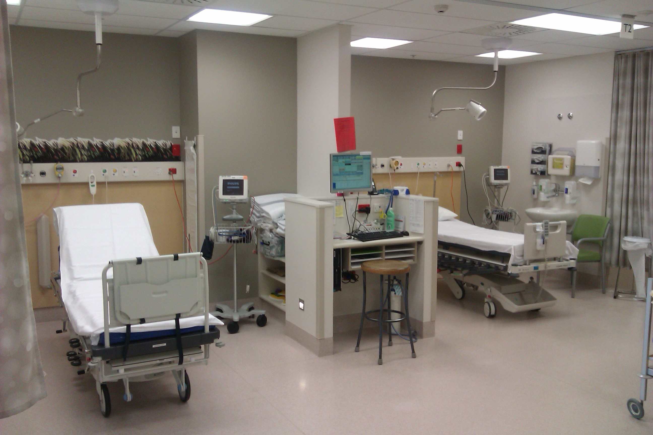

TRIAGE
Patients are allocated a triage code depending on the seriousness of their presentation:
- Triage/code 1: Life threatening- requires immediate attention
- Triage/code 2: Emergency- needs to be seen within 10 minutes
- Triage/code 3: Urgent- we aim to treat these patients within 30 minutes.
- Triage/code 4: Semi urgent - we aim to treat these patients within 60 minutes.
- Triage/code 5: Non-urgent – patients which could be treated by a GP/primary health, care organisation. We aim to treat these patients within two hours.

AMBULANCE CALLS

This has its own distinctive ring and is linked to ambulance control. It is answered by qualified staff only as it will be relaying information about a Trauma such as a motor vehicle accident, medical emergency such as a cardiac or respiratory arrest, incoming helicopter or any information regarding an unwell adult or child. The information is documented and then relayed to the charge nurse, SMO, resus nurse, reception staff and security orderly (if required).

PATHWAYS/FAST TRACK

Some of our ED patients who meet specific protocols are also ‘highlighted’ during the triage process as ‘fast track’ patients.
There are specific guidelines for patients who present for:
Neutropenic Sepsis
Fractured Neck of Femur (#NOF)
Acute Myocardial Infarction (ACS)
Stroke.

DIRECT REFERRALS

On arrival to ED each patient that presents to the ED are assessed by triage staff, there are patients who have had direct referrals to other specialities within the hospital, provided these patients are stable and meet the specific criteria they can be directed from ED to the appropriate area.
These areas include: MAPU, CAU

NURSE INITIATED MEDICATIONS (NIM)

For a portion of our patients their treatment is initiated by our nurses first, using nurse initiated medications. Nurses are required to complete additional learning assessments for each specific medicine in order to administer NIM.
E.g. : Asthma Protocol, paracetamol, ibuprofen, IV morphine, tetracaine eye drops, ADT

CLINICAL TREATMENT AREA
The department is separated into two main areas
Acutes and Sub-acutes
Each nurse is allocated a specific area and group of rooms each shift, despite having individual rooms and patients we strongly encourage teamwork and supporting each other.

Acutes A1-6/psych room
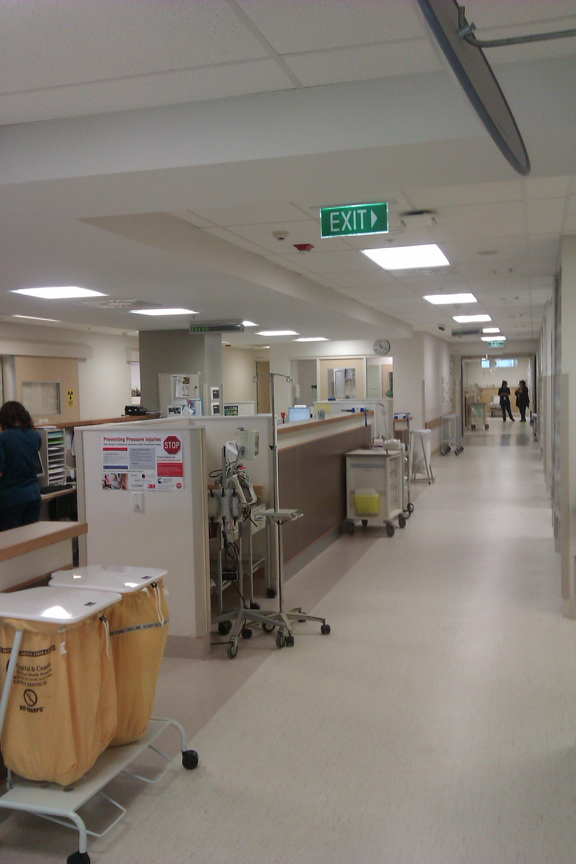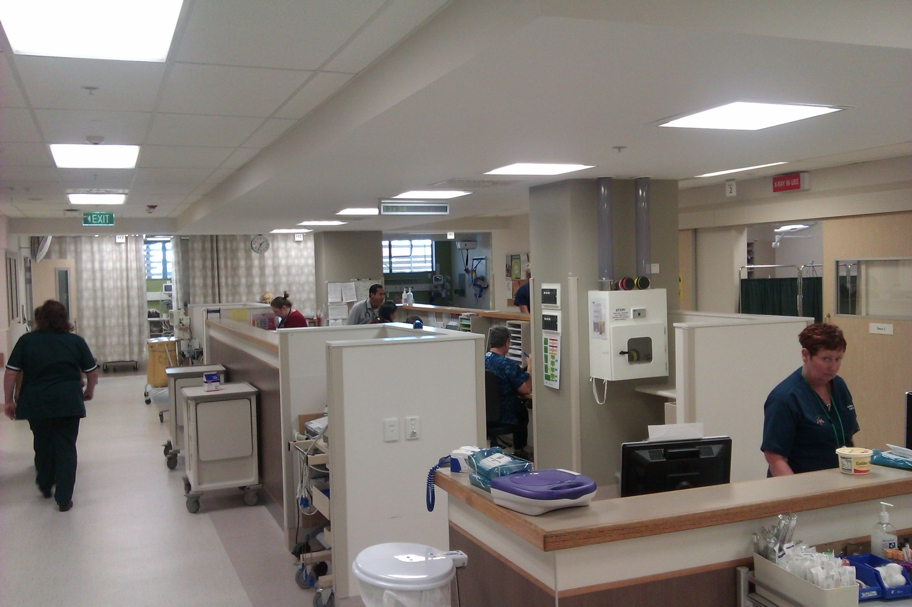
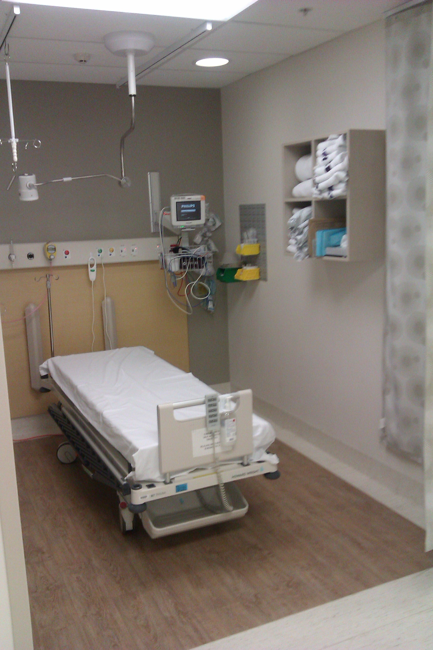

High dependency: H1-3 and Isolation room

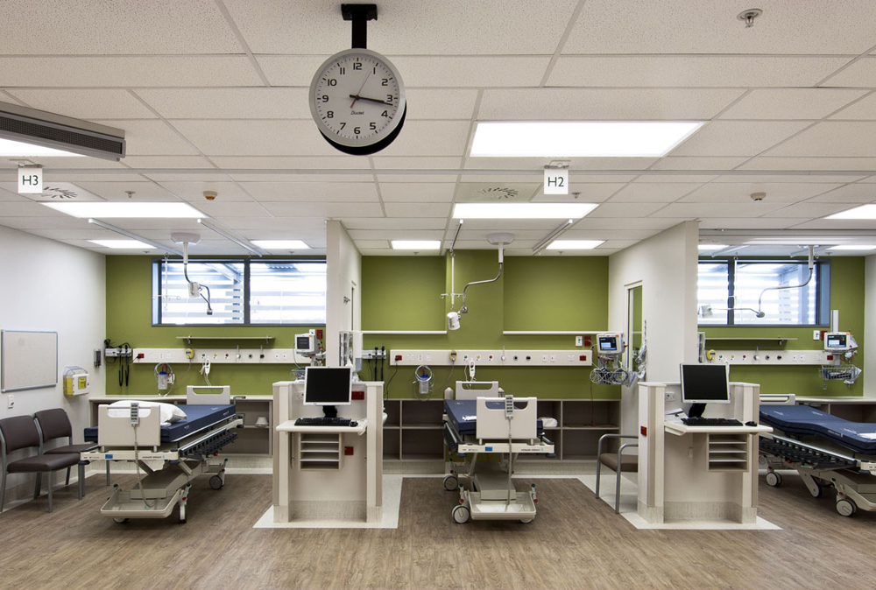

Resus 1, 2, 3 (paediatric resus room)
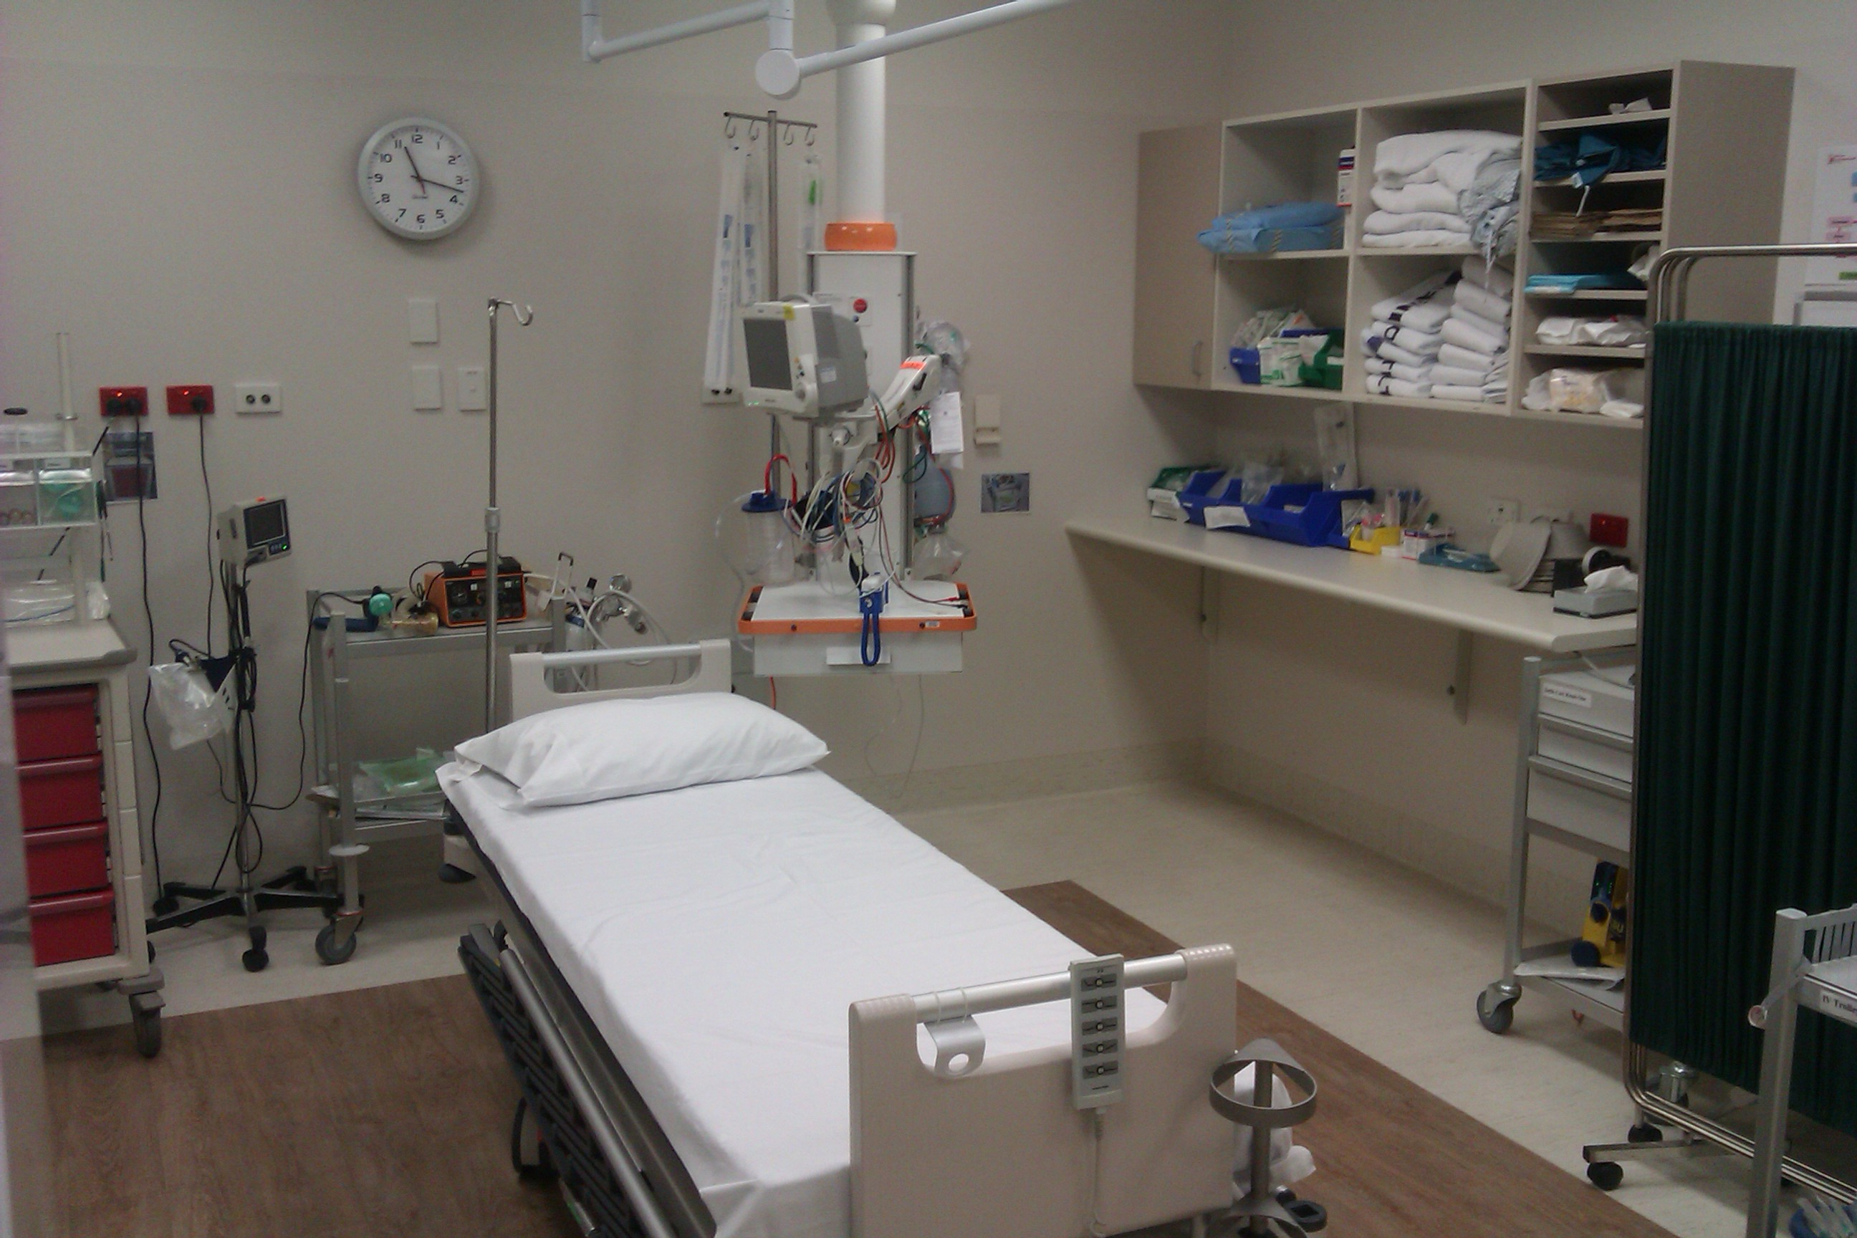

RESUS
- There are 3 resuscitation rooms
- The nurses allocated to work here have had additional training and orientation
- Our most unwell of patients are treated here. We also care for patients that need procedural sedation here.
- As a third year student, this may be an area where you will be placed for a shift. If so, only partake in situations where you feel comfortable.
- At any time, if you are finding it hard to cope with what you are seeing do not feel you have to stay and watch, instead leave quietly and debrief with a nurse

Sub acutes

Cubicles B1– B9, including “the tree hutt” paediatric area with two clinical rooms

This area operates between 1000-2300

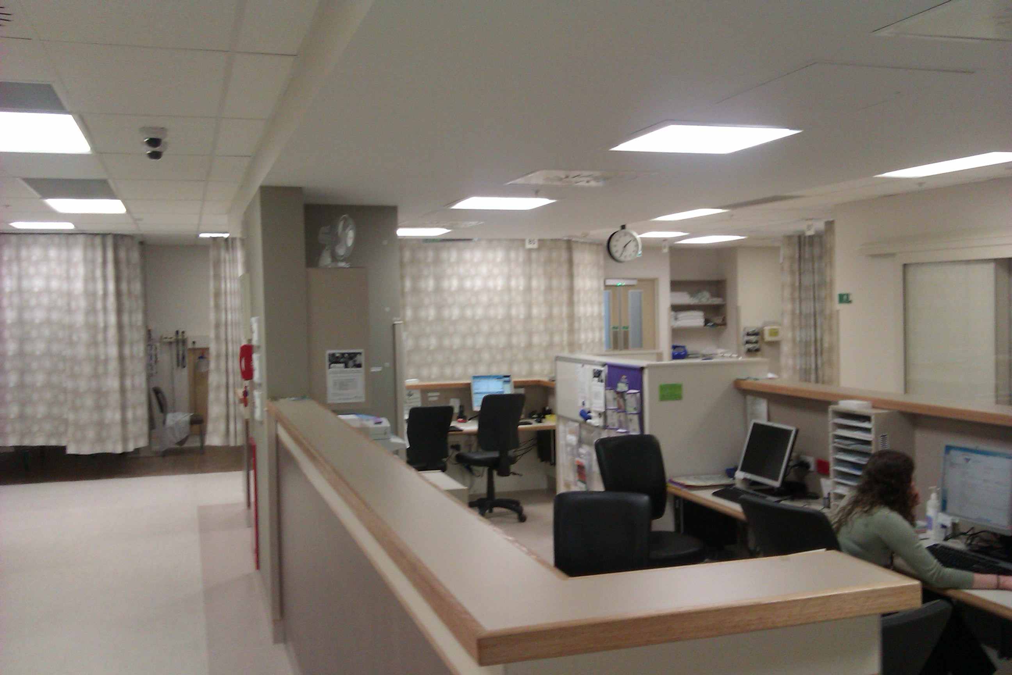

The Tree Hutt
Children’s waiting room
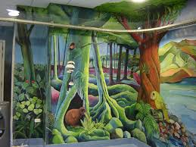

ED x-ray
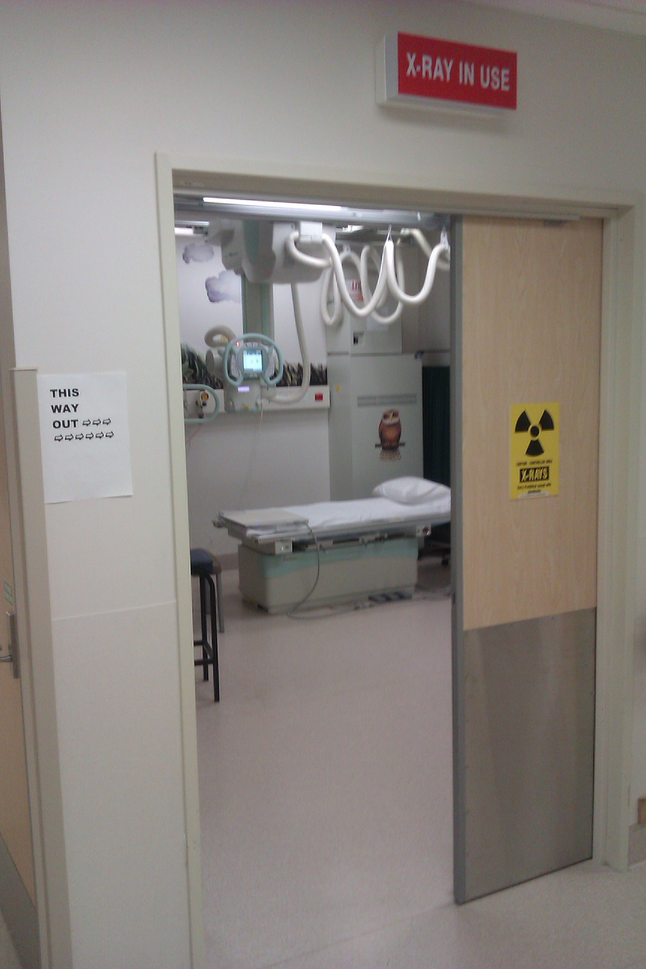

DEPARTMENT WALK THROUGH

Key areas of Note
- Acutes
- Sub acutes
- Resus
- Triage
- Nurse allocation board
- ACNM desk
- Patient Flow Coordinator desk
- SMO desks
- Lamson tube
- Drug room
- Reception
- Manual BP machine
- Security Orderly base
- Sluices
- Policies and Procedures Manuals – including Infection control
- Management Plans
- Hoist
- Staff toilets
- Staff Room
- Education Rooms
- CNM office
- Educator/ACNM office
- Store Rooms
- ED X-ray

NURSES ROLE IN THE EMERGENCY DEPARTMENT

Clinical Nurse Manager Michael Johnson


Charge Nurses (ACNM) Ruth Kerr, Stephanie Beddis, Charlotte Gibson, Kirsteen Haynes

(Dark Blue scrubs)
The Charge Nurses have staff responsibility and are responsible for the administrative and clinical oversight of the Unit on a day-to-day basis.
- Is responsible for the daily rostering shortfall and other rostering requests.
- Is responsible for the daily rostering requirements and other rostering requests
- Provides Clinical expertise and assistance to the staff.
- Facilitates policy and procedural development
Clinical Nurse Specialist (CNS), Doug King, Natalie Wood, Michelle Flaws, Jenny Quin
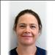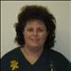
(Black scrubs)
These accredited senior nurses are able to see and treat patients that meet minor injury criteria.
There is a CNS rostered to work in sub-acutes every day.

NURSES ROLE IN THE EMERGENCY DEPARTMENT

Clinical Nurse Educators (CNE) Ben Ross, Tracy Langhorn, and Kyla Rutherford
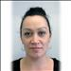
(Black scrubs)

Patient Flow (light blue scrubs)
Beta Waqairawai, Vicki Bulmer, Sarah Denton, Nathan Clark

The patient flow nurses are responsible for the flow of the department and assist with admissions and liaising with other departments/wards

PRIMARY CARE NURSE (PCN): (Grey Scrubs)
- Allocated patients by the ACNM (charge nurse)
- Takes base line recordings. BP, Temp. Heart Rate, Resps and other appropriate procedures i.e. BM, Urine etc. According to patients presenting complaint.
- Takes any other diagnostic procedures requested (once the patient has been assessed by Registrar and/or requested prior to patients arrival by Medical staff) e.g. ECG, Bloods, Radiology.
- Administers medication as prescribed.
- Reports immediately any deterioration in patients condition to Charge Nurse and Medical staff
- Assists colleagues with workload when appropriate.
- Ensures all patient documentation is complete before the patient leaves the department. This includes any education required and follow up advice

OTHER KEY ROLES IN THE DEPARTMENT
Clinical head of department (CHOD)
ANNE CLARKE
SMO (senior medical officer)
 ROSS WILSON
 PATRICIA BAINES
 MIKE SCOTT
 TANYA WILTON
 CRIS SAYOC
LEANA LOUW
DAVID O’BRYNE

FREQUENTLY ASKED QUESTIONS

Q. How will I know who my preceptors are?
A. On the allocation board it will show you who the nurse you will be working with is and where you will be based for the shift. It will also be in the allocation book If you are not allocated a nurse the ACNM will place you with one.
Q. What do I do if I want to change a shift?
A. You must speak to the student nurse preceptor before changing a shift and make your request. You must take into account that we can only have certain numbers of staff that require supervision working at one time. This then needs to be confirmed by the ACNM and educator informed via email
Q. What do I do if I am ill?
A. You must inform the department that you are ill before the start of your shift. When you ring ensure that you ask to speak to the ACNM, your key mentor or Charge nurse manager on Tel5697835 tell them which shift you will be missing and when you intend to return
Q. What does everyone wear?
A. ED nurses wear green or Gray scrubs, ACNM wear dark blue and ED Drs wear light blue.
Q. Where can I put my property?
A. Do not leave any valuables in the staff room. There is a locker room for you to put your property in.

EMERGENCY NURSING ASSESSMENT

Needs to be systematic.
Primary and Secondary Assessments provide the Emergency Nurse with a methodical approach to help identify and prioritize patient needs
PRIMARY ASSESSMENT

A – Airway
B – Breathing
C- Circulation
D – Disability
A V P U
SECONDARY ASSESSMENT

E Expose/ Environmental Control
F Full set of vitals
Five interventions
Facilitate family presence and
G Give comfort measures

ED does not just get Trauma patients!! We have presentations from all age groups with varied complaints.

DOCUMENTATION
All emergency notes and observations are electronic. You will be given a student login/password, keep them confidential. Please enter your full name at the top of the clinical notes.When documenting, follow this format::
- What is the presenting complaint (PC)
- What is the history presenting complaint (HPC) eg how did they injure there leg etc
- Medical History especially relevant history related to this presentation (PMhx)
- Medications relevant to their presentation (Dhx)
- Allergies
- Social history (shx) where they live and with who etc, smoking hx, ETOH hx, family violence
- On examination (OE)
- A,B,C,D are they In pain? What location is the pain? How severe is the pain?
- Any associated symptoms
- What have they done to help their situation if at all – ie analgesia
- Plan

SPECIAL CONSIDERATIONS
Abdominal pain
Don’t forget Last Meal/Drink, Surgical History
Unwell Adult
Medical History, Infectious? Or Infectious contacts
Unwell child
Immunisation History, Weight
Mental health
Known to MH services

PAIN ASSESSMENT
PQRST ASSESSMENT OF PAIN
PROVOCATION/PALLIATION
What were you doing when the pain started? What caused it? Does anything make it better/worse?
QUALITY/QUANTITY
What does your pain feel like? What words would you use to describe your pain?
REGION/RADIATION
Where is your pain? Does the pain go anywhere else?
SEVERITY SCALE
On a scale of1-10 with 1 being no pain and 10 being the worst pain you could imagine. What score do you give your pain right now? What score do you give your pain at its worse?
TIMING/TREATMENT
When did the pain start? How often does it occur? When does it usually occur (night/day)? What have you done to relieve your pain? Was it effective?
- Don’t forget those with chronic pain issues. Do you have a management plan?
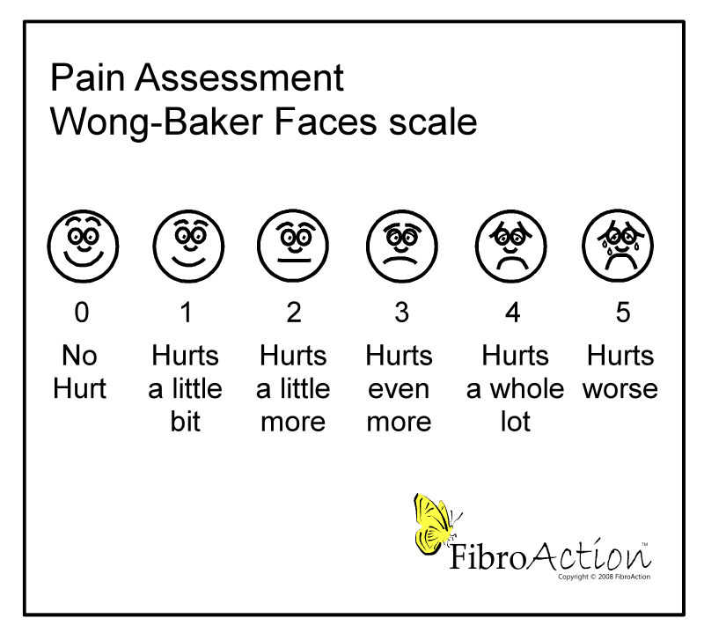

To assist you in understanding how the Patient flows through the department I have compiled a table that will be helpful and that you can review with your preceptor
Triage
- Every patient is triaged on arrival by a triage nurse
- Triage is a clinical decision based on individual needs
- To identify the chief complaint and establish a priorities of care
- Initiation of first-aid / analgesic treatment
- Control of patient flow
- Patient education
- Public relations
- Management of waiting area
- Performs primary survey
- Performs general assessment
- Identifies chief complaint
- Records subjective / objective assessment
- Records pertinent past medical history
- Records current medications
- Records allergies
- Records tetanus status (as appropriate)
- Records vital signs and GCS (as appropriate)

Ongoing assessment and care
- Patient care nurses are responsible for the initial work up of all patients and ongoing reassessment. | - Hourly re-assessment and evaluation of vital signs, or more frequently, as the patient’s condition indicates.  - Uses the EWS and PEWS as a guide for intervention and observation.  - Recognises changes in the patients condition that require notification to senior nursing and medical staff.  - Demonstrates appropriate care of patients property and valuables  - Documents all procedures / events of the Clinical record sheet  - Maintains universal precautions

Whilst you are on your student placement in emergency it will be useful to go through the following checklist with your preceptors to ensure you have gained competence in the following areas.
Airway / Breathing equipment
- Locates and discusses  indications for, and use of: | - Oropharangeal/nasopharyngeal airway  - Bag – valve – mask device  - Suction  -Wall  -Portable  - Oxygen masks  -28% (Venturi)  -Hudson medium concentration  -High flow non-rebreather  - Pulse oximetry  - Endotracheal tubes

Monitoring systems
- Haemodynamic assessment and monitoring  - Defibrillators | - Demonstrates the use of non-invasive monitoring  - Propac monitors  - Discusses indication for lying / standing BP and HR  - Turn on  - Connect cable and if appropriate pads to patient  - Demonstrates changing printer paper
- Wound management  - Immobilisation  - Demonstrates competence using of: | - Locates supplies for burns treatment  - Locates supplies for traumatic wounds  - Locates and identifies indications, and discusses:  - Cervical collar  - Broad arm sling  - High arm sling  - Femur traction splints  - Collar and cuff  - Scott splint  - Thumb spica  - Lamson tube  - Ambulance RT  - Peak flow meters  - Tympanic thermometers

Admission and Transfer*
- Discusses the process to admit a patient to a ward
- Demonstrates the situations where a patient should be escorted
- Discusses the procedures when a patient arrests during a transfer

Discharge instructions*
- Discusses what information should be given to a patient on discharge
- Demonstrates awareness of written resouces available to give patients on discharge
- Discusses what happens with patient notes on discharge

Feedback Form:
At the end of your placement we would appreciate it if you could take 5 mins and complete this feedback form for us….Without your feedback we can’t improve our teaching package.
Thanks, Ben and Tracy
On a scale on 1-10 (1 = worst, 10 = best) how would you rate your ED placement?

What did you enjoy and why?

What did you not enjoy and why?

Did you find your mentor approachable?

What could we do to improve paramedic student placement in ED?

Please give your confidential feedback to Ben Ross
Appendix 1:
How to page
1: Go to internet explorer and click on directory
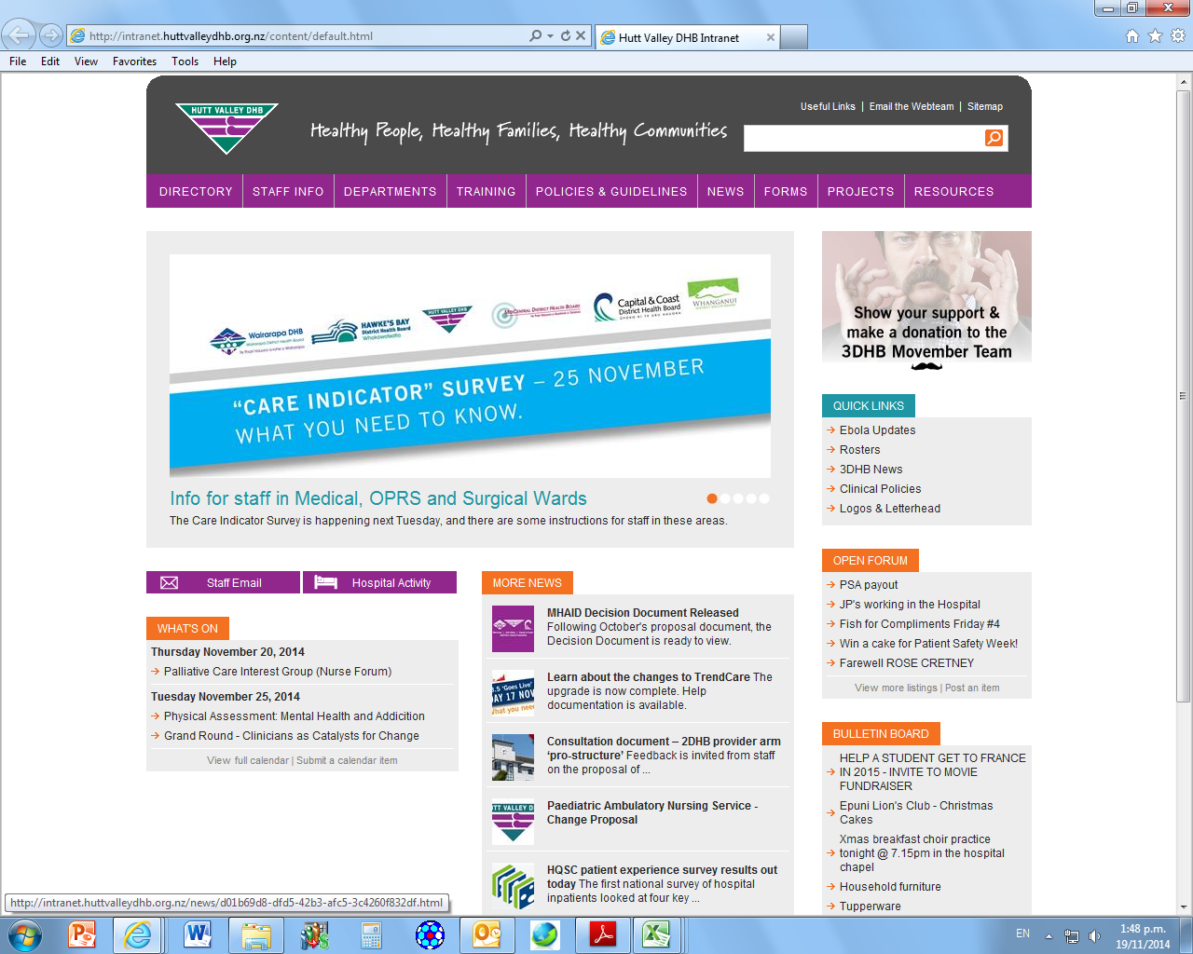

2: Type in emergency (or reg if pageing med reg etc)
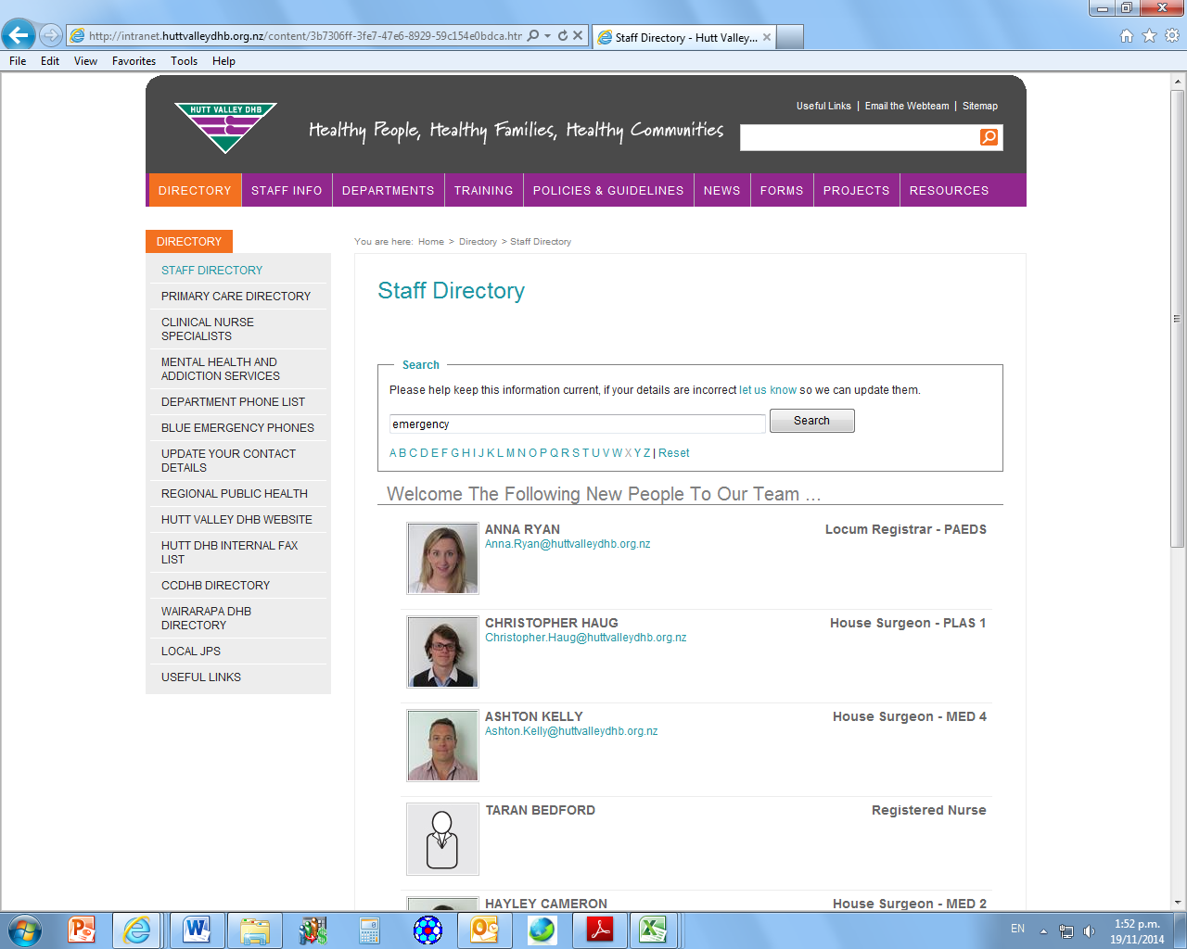

3: Click on emergency orderly 706
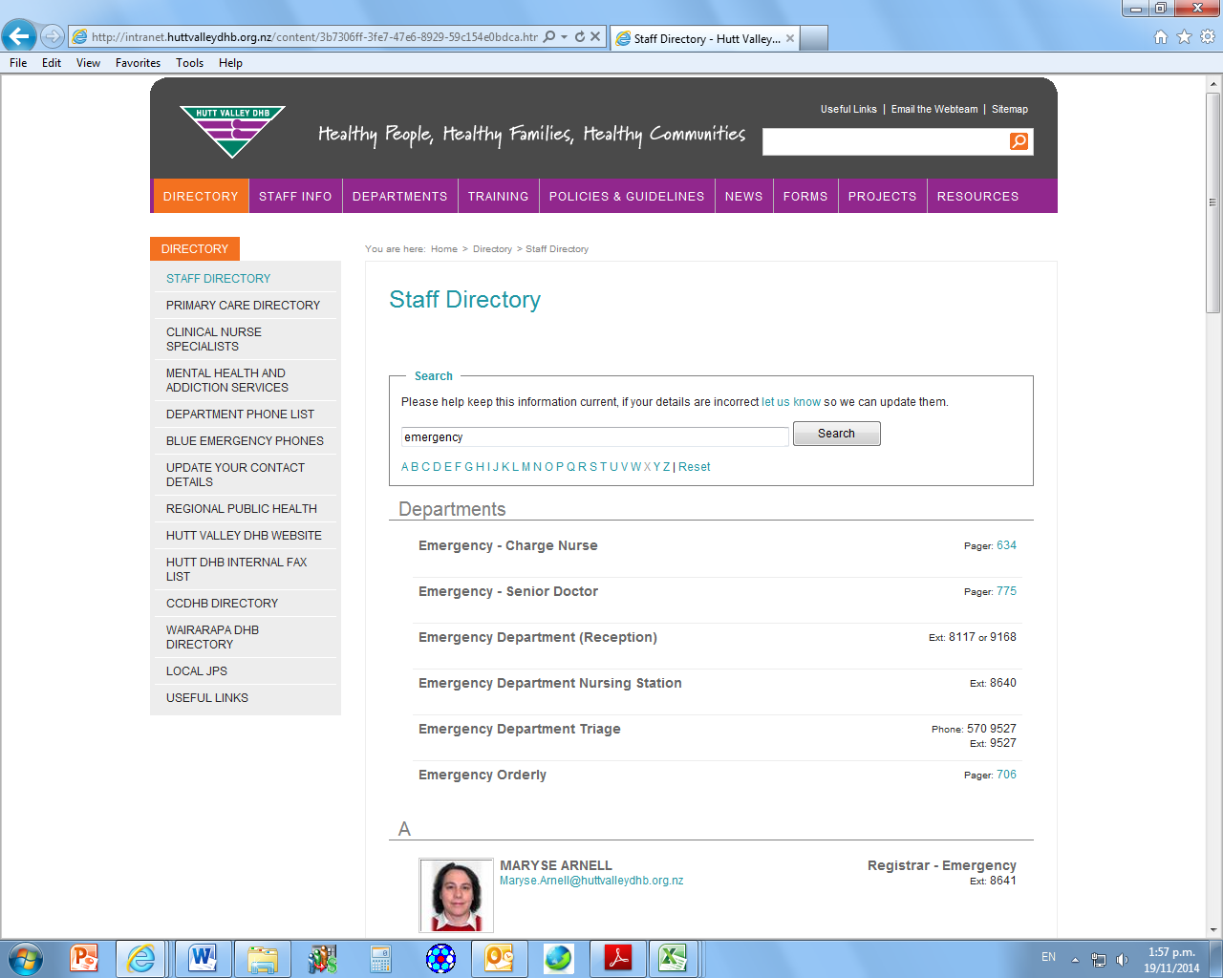
4: type in the patients last name, where they are in the department, and where they need to go. In put your name and ext and send :0)
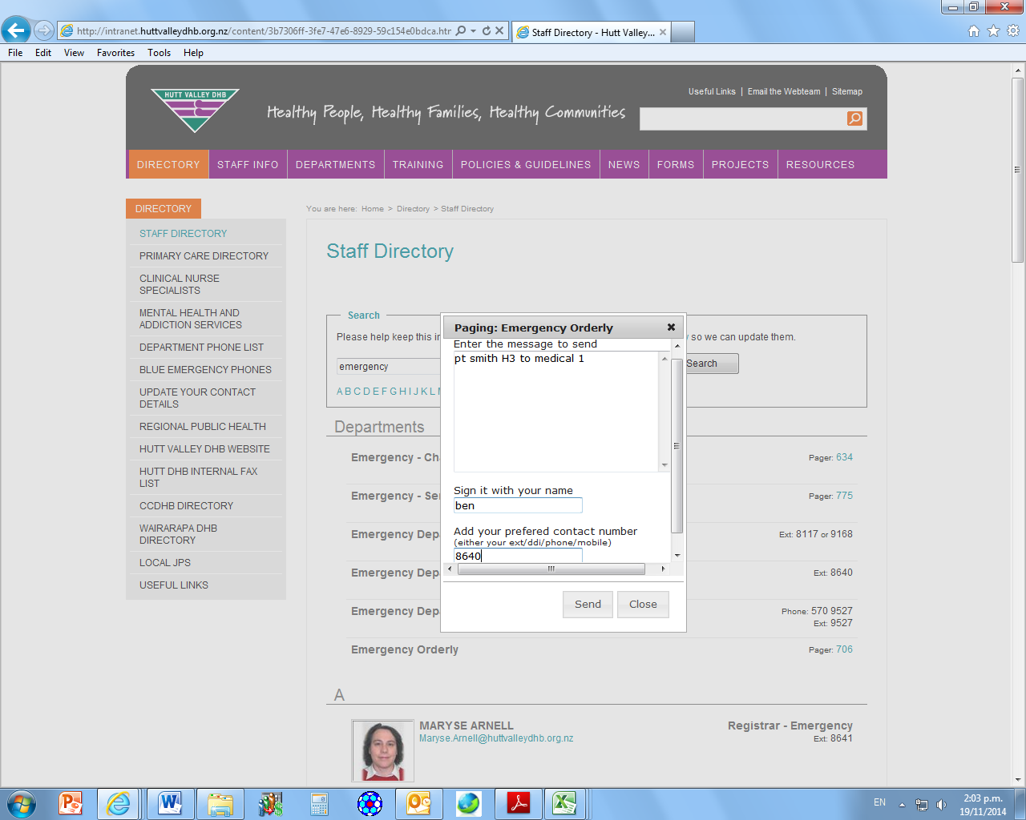

Student Contact Details

Contact details
The staff on the ward/department care about your well-being as well as your education. They will notice and be concerned if you don’t arrive for a planned shift, if there is illness on the ward or in the case of an emergency. They may need to contact you to check you’re ok and to let you know if there needs to be a change to your shifts.
Your Name

Your Home Phone number
Your mobile phone number
Name of emergency contact
Phone number of emergency contact
Please could you provide your contact details and an emergency contact using the form below? This information will be kept by a senior staff member for the length of this placement and then will be destroyed. It will not be shared with anyone else without your permission unless there is an emergency.

Contacting your Tutor
From time to time the staff on the ward may need to contact your tutor regarding your progress, for support or in the case of problems.
Please could you supply the contact details for the tutor that will be supporting you during this placement, in the form below?
Name of Tutor

Phone number for Tutor

Thank you

